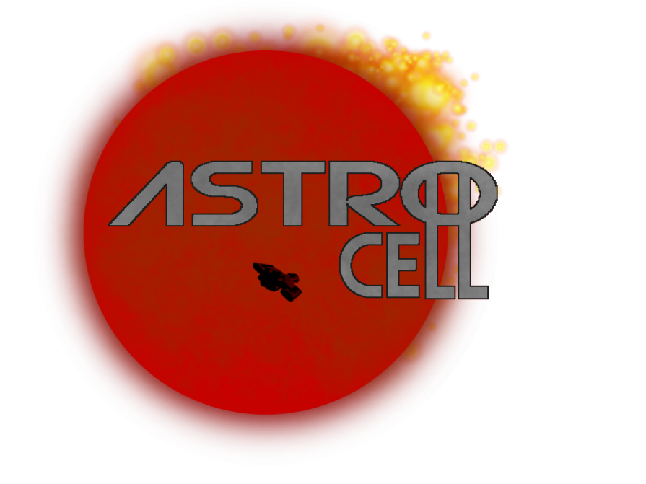

**Astro Cell**

**Team: Matt Mills, Jared Matachun, Jamie Roeger, Ryan Black, Zach Spitzer**

**Table Of Contents**

**------------------**

**Concept 3**

**Game Play 4**

**Prisoner Mechanics 5**

**Guard Mechanics 5**

**Warden Mechanics 6**

**Task Mechanics 6**

**Crafting Mechanics 7**

**Escape Mechanics 7**

**Win Mechanics 7**

**Special Mechanics “we have Hats” 8**

**Look And Feel 8**

**Sound 8**

**Art Style 9,10**

**Stretch additions 11**

**Concept**

Astro-Cell, is a multiplayer puzzle survival game where you play as a prisoner and guards in an intergalactic prison. You and your fellow cell mates must escape your cells and sneak around the prison working towards escaping. You must complete tasks and find items that will aid in your escape while avoiding prison guards and the Warden. If a Guard finds you with contraband you are returned to your cell and must wait to be released by a fellow cellmate or after your confinement time is up. If a guard searches someone with no contraband then they are forced to go update their artificial intelligence. The Warden is the overseer of the guards and has access to a few more mechanisms then the guards do. The warden has access to the prisons security cameras, intercoms, and all restricted locations.

**Game Play**

The prisoners will have to navigate the map completing tasks and finding items that will help make escape possible. This will consist but not be limited to shutting down power, turning off lights(which will result in the red emergency lights activating which have a lower visibility for the guards), breaking into the warden's office, crafting items, activating doors etc. the game will start with a small percentage of prisoners able to leave their cells on start and they will be required to release the remaining prisoners. Together they must accomplish certain tasks that will either a.) work towards escape b.) prevent the guards from capturing and c.) releasing fellow cellmates. Guards will be roaming the halls doing tasks and watching prisoners. They will have the ability to search a prisoner for contraband. If they do not have contraband the guard will be required to go to an update center and download and A.I. update. If the prisoner did have contraband that prisoner will be sent back to his cell and all his contraband will be removed and reset. The warden will have all abilities of the guards as well as access to the intercom system and cameras. Here the warden will be able to see all of the rooms of the prison and the ability to talk to the guards through the intercom.

**Prisoner Mechanics**

Prisoners are bipedal humanoid characters, and upon a session starting, a select number of prisoners will be outside of their cells, with the rest spawning confined in their cells. The prisoners will have a randomly assigned group escape objective. After releasing the rest of the prisoners at the start, they will work together collecting items to craft into more specialized equipment in order to complete tasks. Prisoners can be searched for contraband items; non-contraband items are to be kept on the prisoner, while contraband items will result in them being caught and sent back to the cell to be released again. Prisoners will have access to a menu that shows what items can be crafted, what is required for such items, and where to find them in the level. Items will not tell where they are used, but will mention what they do; it’s up to the prisoners to figure out where items go. Prisoners can use any item on the guards -- most items will fai**l.**

**Guard Mechanics**

Guards can search players which takes 5 seconds. If they search someone and it is wrong they have to go to an AI update center and wait for x amount of time. If they do capture a prisoner they get sent to their cell for x amount of time or if someone lets them out, and they lose all contraband items. These items are placed in a contraband room. Item tasks reset and can be redone. Guards will also have tasks to maintain the ship and repair sabotages. This is so the guards aren’t camping or guarding one area the entire time to give the prisoners a more freeform method to escape.

**Warden Mechanics**

The warden will not be locked in his office on the start. He is the only player who has unrestricted access to his office without penalties. He can communicate to the guards using the intercom system. Using the security camera controls located in the office, the warden can assist the guards in locating specific prisoners if need be. His camera system can highlight when a prisoner is currently performing a task. It is up to the warden to determine whether the task is of an illegal nature or not. He is the only bipedal member of the security team as well, as well as the only non-robotic.

[**Task Mechanics**](https://docs.google.com/document/u/0/d/1gjXRp1AmVwqSTbdsHW2yipRwWsgLUnhvIPyDnPtdCqY/edit)

Tasks are minigames that serve two give benefits to both guards/warden and prisoners. There are many different types of tasks. Sabotage tasks are tasks performed by prisoners to put the guards at a disadvantage, for example cutting the lights or the camera feed. Item acquiring tasks are tasks that prisoners perform to get the items necessary to craft makeshift items to perform certain sabotage tasks or items to hinder the guards (EX: a shank to pop the guards tire). Level opening tasks are prisoner tasks that open rooms that prisoners don't have access to like the Warden's office. Innocent tasks are Prisoner tasks that are completely innocent like serving meals or mopping floors to make it seem to the warden and guards that you're not up to anything fishy. Maintenance tasks are guard/warden tasks that help speed up the game time for the guards to win. Sabotage repair tasks are guard tasks that repair what the mechanics that a prisoner has sabotaged like fixing the power to the lights.

[**Crafting Mechanics**](https://docs.google.com/document/u/0/d/1XCh6-CNDIK6VEVkqy3zFYwtypvFZ1yA8Lvn8vib6u90/edit)

Crafting serves to offer the prisoners access to new areas through the use of crafted items. Crafting will work by the prisoners finding items scattered throughout the prison and bringing them back to a central crafting area in their cell block. Example recipes available include things like rope or a ladder to gain access to high areas, a taser to stun guards, a shank to pop the prison guards tires, a lockpick to gain access into locked cabinets, and many more items. The purpose of this in the game flow is to create a progression system towards the prisoners' escape.

**Escape mechanics**

There are 4 escape conditions for our current map Dark Star Penitentiary. 1.) Escape pods - craft items and unlock the escape pods to escape.2.) bubble wrap trash shoot - gather funds to purchase an excess of glass items to be shipped to the prison warden as gifts to steal the bubble wrap and encase yourselves in bubble wrap and launch yourselves out of the trash shoot. 3.) Hangar Escape -using mining materials to fuel spacecraft’s in the hangar. 4.) armory revolt - hacking into the weapons system to revolt against the prison guards.

[**Win Mechanics**](https://docs.google.com/document/u/0/d/1ftjLWtUo_M0Jd09tLDf6nND5ld4wfZduq7nqqU6VfAo/edit)

The Guards/Warden wins if the timer goes down to 0, or all of the prisoners are in confinement. The Prisoners win if they escape the astro jail. At the beginning of the game the prisoners are given a random win condition that they have to use as their method of escape. The guards and warden are completely unaware of this condition.

**Special Mechanics**

There is a tie condition if the prisoners blow up the reactor and eliminate everyone in the jail. This is a last ditch condition that prisoners can go for if the guards are about to win and they don't want to give them the glory of the win condition. The prisoners also have the ability to change their escape condition on the warden's office computer. The prisoner would have to break into the office and hack the warden's computer in order to achieve this. Before a game starts the host of the game also has the ability to set the number of prisoners and guards, and have the ability to modify the game's rules and server settings. Oh and yes … we are implementing hats.

**Sound**

Being a sci-fi focused game, we opted for a more science fiction-oriented soundtrack. The typical noises you would hear in say a spacecraft or station -- beeps and boops from the various machines (in this case, to indicate the player has interacted with something). This will be accompanied by an appropriate background music selection.

[**Art Style**](https://docs.google.com/document/d/1jahZ5zL4a5LR3LSiLAyPpHCWULCqVn8Yyr4T6hqMWxI/edit)

The game should look similar to among us and fall guys with a light color pallet and simple flow map. In terms of design inspirations, it will be kept within the bounds of science fiction, to fit with the theme. Mechanical components abound, especially in the mining and material processing sections. Perhaps some digital panels for the computer systems and door controls. Characters will have the simplicity of Among Us and Fall Guys. Since our maps will be in different locations possibly (our two named maps are in space and in a snowy landscape, respectively), some inspiration may be taken from the Star Wars universe in terms of concept.

**Stretch Additions**

Octocop

Additional map “howling wind institution”